 | National University  of Computer and Emerging Sciences  Chiniot-Faisalabad Campus  Department of Artificial Intelligence and Data Science | 
Course Code | AI4002
Course Title | Computer Vision – Lab
Lab Task | 7
Due Date (A Section) | 09:00 pm - 07 October 2025
Due Date (B Section) | 09:00 pm - 10 October 2025
Instructions:
- Rename this Word file as LT7_22F-3170
- If found plagiarism, straight zero will be marked against task.
- Submit task on Due Date. No Late Submission will be Tolerated.

Question 1
Write a Python code that reads the attached 2D Binary Images. Use the OpenCV library to implement different Morphological Operations like:
- Erosion
- Dilation
- Opening
- Closing
- Boundary (Internal)
- Boundary (External)

At the End, the Original Image with each Operation, will be shown side by side.

Note: Structural Element size and shape is your choice, but you should have the reason.

Code
import cv2
import numpy as np
import matplotlib.pyplot as plt

img = cv2.imread('blobs.png', cv2.IMREAD_GRAYSCALE)
thresh_value, binary = cv2.threshold(img, 127, 255, cv2.THRESH_BINARY)

# Using a 3x3 square kernel — commonly used for basic morphological tasks.
# Reason: Small kernel preserves structure but effectively removes small noise.
kernel = cv2.getStructuringElement(cv2.MORPH_RECT, (3, 3))

# Erosion — shrinks white regions
erosion = cv2.erode(binary, kernel, iterations=1)

# Dilation — expands white regions
dilation = cv2.dilate(binary, kernel, iterations=1)

# Opening = Erosion followed by Dilation (removes small noise)
opening = cv2.morphologyEx(binary, cv2.MORPH_OPEN, kernel)

# Closing = Dilation followed by Erosion (fills small holes)
closing = cv2.morphologyEx(binary, cv2.MORPH_CLOSE, kernel)

# Internal Boundary = Original - Eroded
boundary_internal = cv2.subtract(binary, erosion)

# External Boundary = Dilated - Original
boundary_external = cv2.subtract(dilation, binary)

titles = [
'Original',
'Erosion',
'Dilation',
'Opening',
'Closing',
'Boundary (Internal)',
'Boundary (External)'
]

images = [
binary,
erosion,
dilation,
opening,
closing,
boundary_internal,
boundary_external
]

plt.figure(figsize=(15, 8))
for i in range(7):
plt.subplot(2, 4, i + 1)
plt.imshow(images[i], cmap='gray')
plt.title(titles[i])
plt.axis('off')

plt.tight_layout()
plt.show()

Screenshot
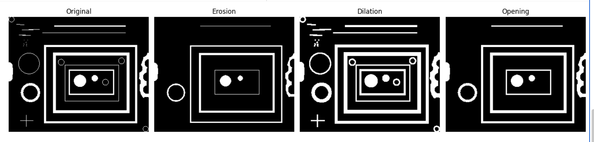

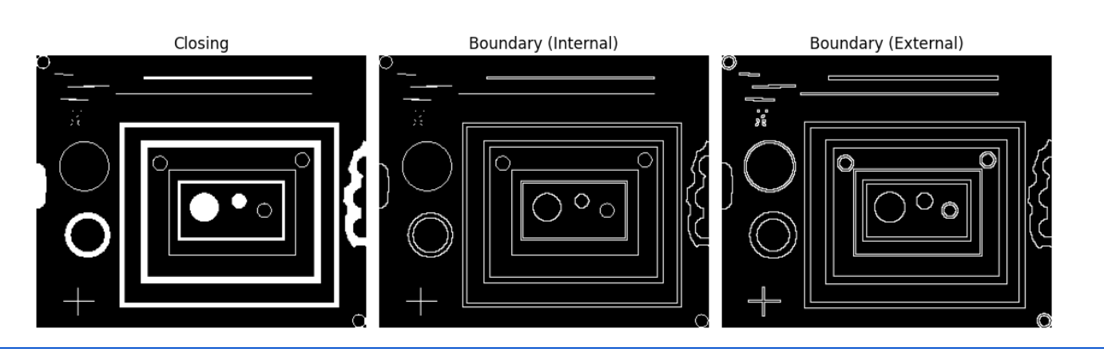
import cv2
import numpy as np
import matplotlib.pyplot as plt

img = cv2.imread('wirebond.tif', cv2.IMREAD_GRAYSCALE)
thresh_value, binary = cv2.threshold(img, 127, 255, cv2.THRESH_BINARY)

# Using a 3x3 square kernel — commonly used for basic morphological tasks.
# Reason: Small kernel preserves structure but effectively removes small noise.
kernel = cv2.getStructuringElement(cv2.MORPH_RECT, (3, 3))

# Erosion — shrinks white regions
erosion = cv2.erode(binary, kernel, iterations=1)

# Dilation — expands white regions
dilation = cv2.dilate(binary, kernel, iterations=1)

# Opening = Erosion followed by Dilation (removes small noise)
opening = cv2.morphologyEx(binary, cv2.MORPH_OPEN, kernel)

# Closing = Dilation followed by Erosion (fills small holes)
closing = cv2.morphologyEx(binary, cv2.MORPH_CLOSE, kernel)

# Internal Boundary = Original - Eroded
boundary_internal = cv2.subtract(binary, erosion)

# External Boundary = Dilated - Original
boundary_external = cv2.subtract(dilation, binary)

titles = [
'Original',
'Erosion',
'Dilation',
'Opening',
'Closing',
'Boundary (Internal)',
'Boundary (External)'
]

images = [
binary,
erosion,
dilation,
opening,
closing,
boundary_internal,
boundary_external
]

plt.figure(figsize=(15, 8))
for i in range(7):
plt.subplot(2, 4, i + 1)
plt.imshow(images[i], cmap='gray')
plt.title(titles[i])
plt.axis('off')

plt.tight_layout()
plt.show()

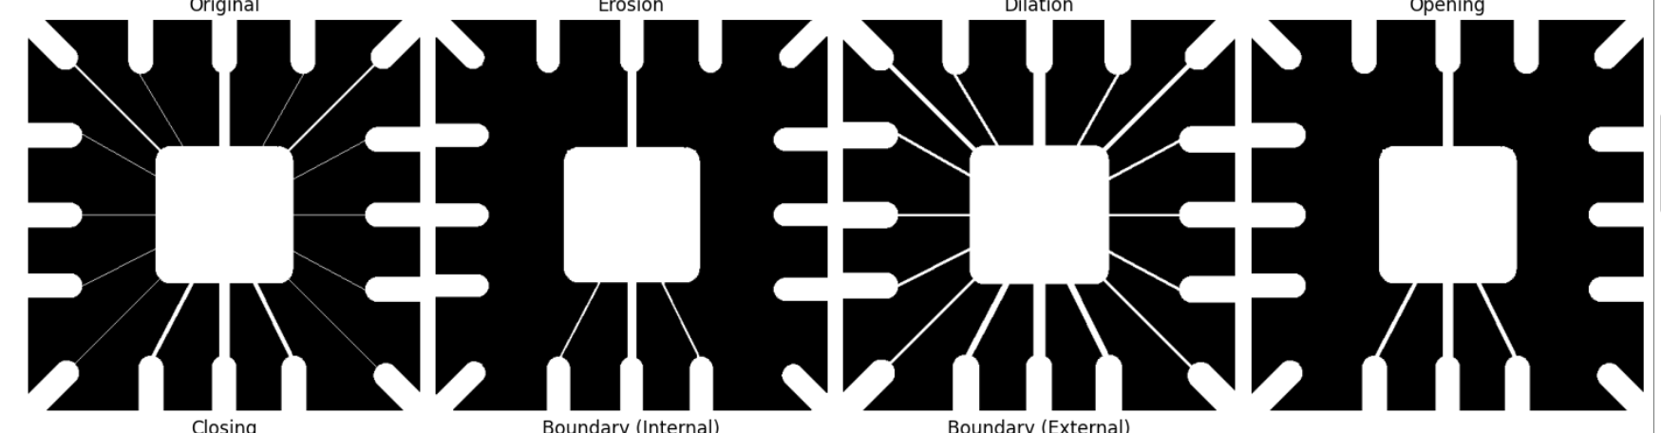

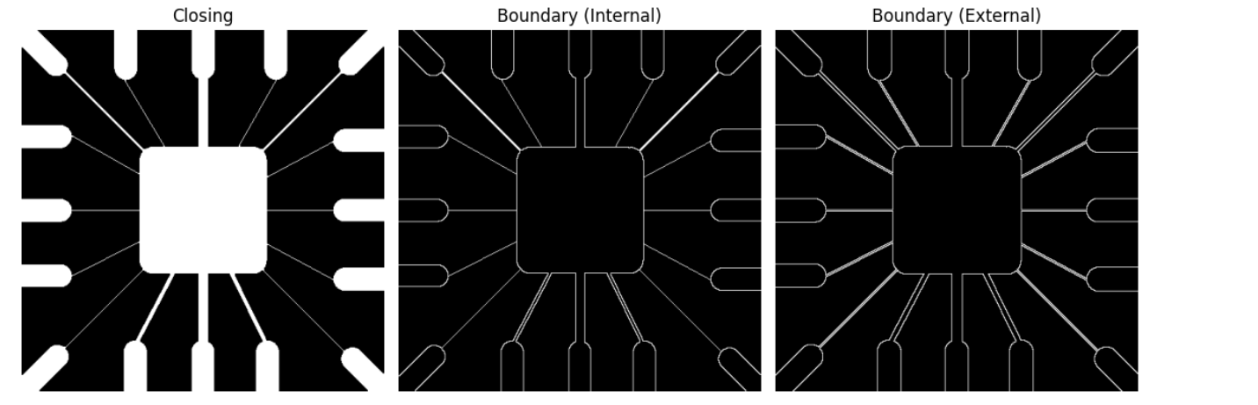

Question 2
Write a Python code that reads the attached 2D Grayscale Images. Use the OpenCV library to:
Apply thresholding to get the liquid as a white object
Apply the appropriate morphological operation to remove noise
Find the area of the liquid
Highlight the boundary of the bottle with half/low liquid
At the End, the Original Image with the Highlighted Image will be shown side by side.

Code
import cv2
import numpy as np
import matplotlib.pyplot as plt
img = cv2.imread('bottles.jpg', cv2.IMREAD_GRAYSCALE)
_, binary = cv2.threshold(img, 120, 255, cv2.THRESH_BINARY_INV)
kernel = cv2.getStructuringElement(cv2.MORPH_ELLIPSE, (5, 5))
cleaned = cv2.morphologyEx(binary, cv2.MORPH_OPEN, kernel)
contours, _ = cv2.findContours(cleaned, cv2.RETR_EXTERNAL, cv2.CHAIN_APPROX_SIMPLE)
highlighted = cv2.cvtColor(img, cv2.COLOR_GRAY2BGR)
total_area = 0
for cnt in contours:
area = cv2.contourArea(cnt)
total_area += area
bottle_area = img.shape[0] * img.shape[1]
liquid_percentage = (total_area / bottle_area) * 100
# If liquid <= 50%, highlight boundary with color
if liquid_percentage <= 50:
cv2.drawContours(highlighted, contours, -1, (0, 0, 255), 2)
else:
cv2.drawContours(highlighted, contours, -1, (0, 255, 0), 2)
plt.figure(figsize=(10, 5))
plt.subplot(1, 2, 1)
plt.imshow(img, cmap='gray')
plt.title('Original Grayscale Image')
plt.axis('off')

plt.subplot(1, 2, 2)
plt.imshow(highlighted)
plt.title(f'Highlighted (Liquid Area: {liquid_percentage:.2f}%)')
plt.axis('off')
plt.tight_layout()
plt.show()

Screenshot
